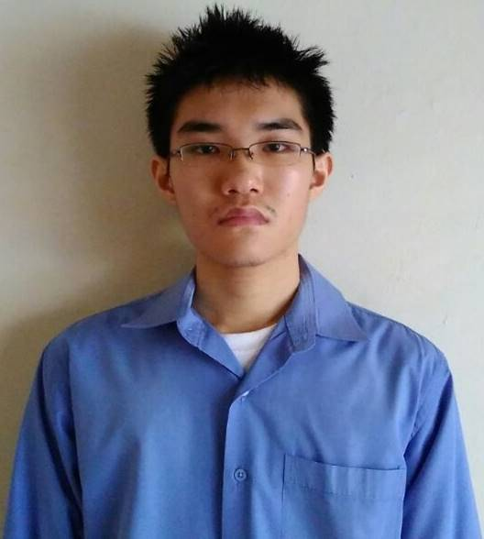CURRICULUM VITAE

Name : Kurniadi

Date of Birth : Jakarta, 27 April 1992

Address : Perumahan Sunter Metro C 22, Papanggo,Tanjung Priok, Jakarta Utara, 14340

Phone : 0899 0371 389

[Type a quote from the document or the summary of an interesting point. You can position the text box anywhere in the document. Use the Drawing Tools tab to change the formatting of the pull quote text box.]

[Type a quote from the document or the summary of an interesting point. You can position the text box anywhere in the document. Use the Drawing Tools tab to change the formatting of the pull quote text box.]

E-Mail : kurniadi.husen@gmail.com

Status : Single

Sex : Male

Pendidikan

**Education**

**Bekerja**

1999 - 2005 : Sekolah Dasar (SD) Dharma Budhi Bhakti

**Work Experience**

Pengalaman Bekerja

2007 – 2008 : Inventory Staff at Toko Kaca Moroseneng

2009 – 2010 : Housekeeper at Sun Lake Hotel

2011 – 2014 :

* Insurance Salesperson at Prudential Life Assurance
* Herbal Medicine Salesperson at Accelerate Business Eminence

2015 – Sekarang :

Keahlian

[Type a quote from the document or the summary of an interesting point. You can position the text box anywhere in the document. Use the Drawing Tools tab to change the formatting of the pull quote text box.]

[Type a quote from the document or the summary of an interesting point. You can position the text box anywhere in the document. Use the Drawing Tools tab to change the formatting of the pull quote text box.]

* FASTPAY Flight and Train Ticket Salesperson
* Online Salesperson at Bukalapak, Elevenia, Kaskus, and Tokopedia

**Skills**

* Basic English
* Microsoft Excel
* Microsoft Power Point
* Microsoft Word